Project Title

A Minor/ Major Project Report
Submitted in Partial fulfilment for the award of
Bachelor of Technology in Computer Science & Engineering

Submitted to
RAJIV GANDHI PROUDYOGIKI VISHWAVIDYALAYA
BHOPAL (M.P)

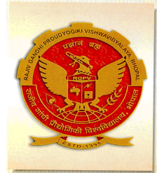

MINOR/ MAJOR PROJECT REPORT

Submitted by
Student’s Name (Enroll No)
Student’s Name (Enroll No)
Student’s Name (Enroll No)
Student’s Name (Enroll No)

Under the supervision of
Prof. xx.yy.zz


Department of Computer Science & Engineering
Lakshmi Narain College of Technology & Science, Bhopal (M.P.)
Session 2025-26

